01st November 2017

**YOKOHAMA Develops Informatics-based Design for Materials and Tyres**

YOKOHAMA has developed a new tyre design technology that applies informatics to the development of rubber materials used in tyres and to tyre shape design. The new technology’s key feature is its use of AI (machine learning) to conduct information and knowledge searches, which is expected to greatly increase the speed and precision of the development new high-performance tyres.   
Over the years, YOKOHAMA has aggressively applied simulation technologies to its development of rubber materials and tyre shape design. For example, in 2005 the Company developed a highly precise multi-scale simulation technology and a multi-performance map that displays numerous optimum designs in a map-like configuration. In 2015, it developed a simulation technology for multi-objective design exploration of rubber materials that has enabled it to create models of a huge number of virtual rubber material morphologies.   
  
The new technology is an advanced version of these previous technologies. The new technology uses AI (machine learning) to conduct information and knowledge searches previously performed by technicians. In addition to shortening the time required to run such searches, the use of AI leads to a more objective and quantitative analysis of the factors that will contribute to a tyre design with a balanced array of performance attributes suitable for various product categories. For example, when developing a tyre that delivers superior performance in two areas normally thought to work against each other, such as fuel efficiency and abrasion resistance, YOKOHAMA used the new technology during the rubber material design stage (materials informatics) to determine the optimal range of values for the size of the compound filler and the thickness of the bound rubber layer formed on the filler surface. Similarly, the technology contributes to the design of tyre shapes by generating the optimal size for the radius of the curvature of the tyre’s cross-section.   
  
The new technology also makes it possible to acquire data from a vast design space that far exceeds the scope of previous studies. This will enable YOKOHAMA researchers to obtain new design factors that lead to new breakthroughs. They also will be able to analyse the mechanisms important to each design factor, which will help them come up with new development approaches based on those mechanisms.  
  
Data science, AI, and other informatics techniques have played an increasingly important role in the development of products and technologies in recent years. YOKOHAMA will make extensive use of these advanced technologies to develop products that meet user needs and to promote the development of innovative products that deliver new value.

##### *Graphical image of the informatics-based design for materials and tyres*

The use of informatics (the combination of data science and simulation technology) enables the speedy design of new materials and tyres by facilitating the discovery of information and knowledge within certain parameter, conditional and multi-scale spaces.

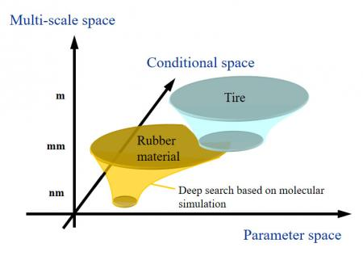

●Parameter space: The space determined by the parameters for special characteristics of tyre shape and structure and the parameters for rubber materials.  
●Conditional space: The space determined by physical and chemical phenomena, limitations and load conditions, and values for targeted characteristics.  
●Multi-scale space: The space determined by various scales.

##### *Information and knowledge discovery process using informatics in design of tyre shape*

